(Faith in Action)
Alston House, White Cross Business Park, Lancaster LA1 4XQ
Registered CIO Charity number 1186017

PROJECT ASSISTANT (COMMUNICATIONS & ADMINISTRATION)
Post title: Project Assistant (Communications & Administration)
Employed by: Trustees of The Olive Branch
Hours: 17 hours per week
Salary: £ 9,777 pa (£23,005 pro rata)
Location: The Olive Branch (Faith in Action) at Alston House, White Cross, Lancaster

- BACKGROUND
The Olive Branch (Faith in Action) is a Lancaster-based charity founded in 2004. It has its roots firmly in the Christian faith while being grounded in the local community.

Our objectives are:
  - The relief of poverty, hardship and distress, in particular but not exclusively among homeless people and those people affected by debt and substance misuse, by the provision of shelter, food, clothing, advice, information, counselling, training and by such other charitable means as the trustees shall from time to time determine.
  - The advancement of the Christian faith.

To achieve these objectives, our work currently has two areas of focus - namely a foodbank and a ‘drop-in’ place of welcome and support for those experiencing hardship.
Two years ago our work was recognised with The Queen’s Award for Voluntary Service (QAVS), a high achievement for a small organisation like ourselves.

We currently employ three members of staff, who manage day to day operations and support our dedicated and diverse team of over 30 volunteers. The staff team consists of a Project Manager, an Assistant Project Manager and a Project Assistant (Communications & Administration). All the posts are part-time.
The Olive Branch is privileged to enjoy tremendous support from people in and around Lancaster. As well as through volunteering, their support comes in the form of contributions for the foodbank or as financial donations, both direct from individuals and also through churches, schools, businesses and other local organisations.
Alongside these valued donations from the community, we rely also on grants for part of our income and have benefitted from the services of a dedicated volunteer Fund-raiser.

- JOB DESCRIPTION: THE PURPOSE AND DUTIES OF THE PROJECT ASSISTANT POST
This post develops the work undertaken by our current Project Assistant, who will be moving on from The Olive Branch in the near future.

The overall purpose of the post is to support the managers and trustees to resource and deliver our day to day work and so to meet our charitable objectives.

The post will encompass two areas of work (Comms and Admin), each with its own purpose and tasks but with some overlap.

- Communications and social media. The purpose of this aspect is to promote the work of The Olive Branch through social media, website, print and other means. This promotion plays a significant role in maintaining our donor and support base.
The main tasks will include:
- Carry out marketing, publicity and promotion of The Olive Branch through its website and through print, social media (specifically Facebook at present), newsletters, etc.
- Correspond with local churches and other organisations to provide material for their own newsletters, websites, etc.
- Express thanks and appreciation to those who respond to appeals by making donations
- Contribute to the production of promotional resources (eg videos), alongside managers
- Explore opportunities for new avenues of communication.

- Administration. The purpose of this aspect is to carry out administrative tasks which underpin day to day operations of The Olive Branch and monthly trustee meetings.
The main tasks will include:
- Monitor communications (email inboxes and phone messages)
- Liaise with suppliers for orders of food and other requirements
- Support the process for volunteer applications
- Support the process for drawing up volunteer rotas
- Monitor and ‘tidy’ the confidential database of guest information
- Upload invoices and expense claims for payment
- Carry out filing, printing etc as required
- Attend and minute monthly trustee meetings and the Annual General Meeting
- Update the Charity Commission website with trustee details when required

Prayer is central to the life of The Olive Branch and the post-holder will be expected to take part in our short daily prayer times.

- PERSON SPECIFICATION
Post title: PROJECT ASSISTANT (COMMUNICATIONS & ADMINISTRATION)
The person we are seeking to appoint is likely to have the following qualities and expertise:
Item | Essential /non-negotiable | Desirable / ideal
 | Values and Personal Qualities
1 | Personal Christian faith | Active member of a local church
2 | Having compassion for people who find themselves in difficult circumstances | Experience of working with people in need of support
3 | Self-motivated with good personal organisation
4 | Able to establish and maintain congenial working relationships
5 | Able to work both independently and as a team member
6 | Having a flexible approach and a problem-solving attitude
 | Communication skills
7 | High standard of written communication (fluent, creative and engaging content with sound grammar, accurate punctuation and spelling) | Experience of producing promotional material for an organisation
8 | Clear and courteous verbal communication | Experience of communicating with people who are in distress
9 | Able to adapt communication to different contexts
10 | Understanding of and respect for confidentiality (including verbal, written and online information; for both personal and organisational information) | Experience of working in situations where confidentiality has been required
 | Social media skills
11 | Proficient in using social media including Facebook | Experience in using social media creatively to promote an organisation and its activities, eg using Meta Business Suite
12 |  | Experience of developing website content
13 | Pro-active in trying creative new ideas for social media engagement | Knowledge of current and emerging social media platforms and their use
 | Administration skills
14 | Proficient use of MS Office software | Experience of using MS Office in a work environment (specifically Excel and Word)
15 |  | Experience of using accounting software (specifically ExpensePlus)

Please note: a basic DBS (Disclosure and Barring Service) check will be carried out on appointment, alongside confirmation of the applicant’s right to work in the UK.

- NEXT STEPS
Does this stimulating, varied and significant role interest you and match your expertise?

If so, we would love to hear from you.

Please see overleaf for guidance on making an application, and timescales for the selection process.

To submit an application or to find out more, please email HR@the-olivebranch.org.uk.

THANK YOU for your interest in The OIive Branch (Faith in Action).
www.the-olivebranch.org.uk

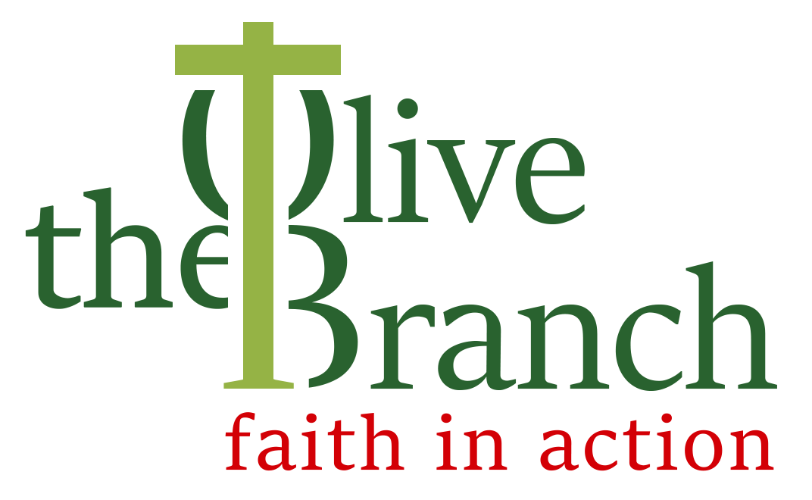
PROJECT ASSISTANT (COMMUNICATIONS & ADMINISTRATION) vacancy 2023
GUIDANCE FOR APPLICANTS
Thank you for your interest in this vacancy. The following notes are provided for your guidance, along with the Job Description and Person Specification.
- Useful information about the work, background and ethos of The Olive Branch is available on our website at https://the-olivebranch.org.uk. Here you will also find our latest newsletter and a link to our Facebook pages.
- You are welcome to discuss your interest in this post with the Project Manager (01524 555715). If you are unfamiliar with the work of The Olive Branch, you are welcome to visit by arrangement.
- Applications must be submitted by email attachment to HR@the-olivebranch.org.uk by 6pm on Tuesday 19th September.
- Your application should show clearly how you meet the requirements of the Person Specification, using specific examples as evidence wherever possible. If you have a CV and wish to send it as supporting information, that will be welcome.
- All applications should also include the names and contact details of two people from whom we can request references. One of these should be your current or most recent employer and one should be your church leader/minister.
- The selection panel will shortlist applications against the Person Specification. Those shortlisted will be notified by 6pm on Wednesday 20th September. References will be requested at this point (unless you inform us of circumstances which would make this inappropriate).
- Interviews for shortlisted candidates will be held on Thursday 28th September at The Olive Branch (Faith in Action), Alston House, White Cross Business Park, Lancaster LA1 4XQ
- The successful candidate will be notified as soon as possible after interview, and the offer will be confirmed once satisfactory DBS check and references have been received.
- There will be a 6-month probation period for the post. The appointment will then be confirmed, subject to performance in post.
- If you have a disability or other special requirements, please include details in your application so that any necessary arrangements can be made for you.

We hope this guidance has been helpful and we look forward to hearing from you.
THANK YOU for your interest in The OIive Branch (Faith in Action).
www.the-olivebranch.org.uk

