Referral For an Emergency Food Parcel Date:
(Please give or email this form to the person being referred in addition to sending to us, and ask them to bring it with them when they come to collect their food)

Recipient’s details
Name:
Contact phone number:
Address:

Date of birth:
Number of adults/children in household:
Brief description of reason they need emergency food:

Referral agency details
Referral agency:
Contact name:
Contact phone/email:
Please note: we will normally provide up to 5 food parcels in one period of need. Any further support beyond this will be subject to review, requiring evidence of the recipient engaging closely with support services and/or their situation having a fixed duration.
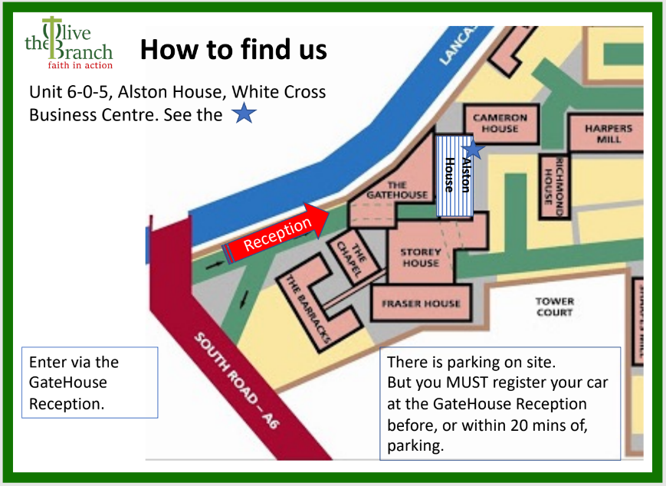
If you are able to, please bring some bags with you.
Please don’t forget to bring this form with you, either show us on your phone or print off and bring with you.
Our opening hours are 11am - 1pm and 1.30pm - 3.30pm on Mondays, Tuesdays, Wednesdays and Fridays.

